**Mayookha Coffee Shop**

The Mayookha Coffee Shop database is an SQL Server Management Studio (SSMS) project that encompasses all the necessary tasks, from data import into SSMS to data extraction through essential and critical queries. This document outlines the comprehensive steps involved in managing the database, providing detailed instructions and guidance for each stage of the process.

# **Stage 1A: Converting the excel file to csv file**

* We convert Excel files to CSV format for SSMS because it's a simpler and more compatible format for importing data into the database.
* CSV files are plain text, so they don't include any formatting or formulas, making them easier to work with and less likely to cause errors during import.
* They also allow for faster processing and are more convenient for automation and scripting.
* Additionally, CSV files avoid compatibility issues that may arise from Excel's complex features.

# **Stage 1B: Creating database folder in SSMS**

This can be accomplished in two ways.

The first option is

* **Open SSMS** and connect to your SQL Server instance.
* **Connect to the Server**: In the **Object Explorer** pane, right-click on the **Databases** node and click on new database from the menu.
* **Create the Database**: In the **New Database** dialog box, enter the **name** of the database.
* **Finalize and Create**: by clicking Ok.

Another approach is

* **Open SSMS** and connect to your SQL Server instance.
* **Connect to the Server**: In the **Object Explorer** pane, right-click on the **Databases** node and click on new database from the menu.
* Click on new query and write **CREATE DATABASE Mayookha_Coffee_shop_db**
* Select this statement and run the query
* Refresh in at Object explorer and now we can see the newly created database under the name give.

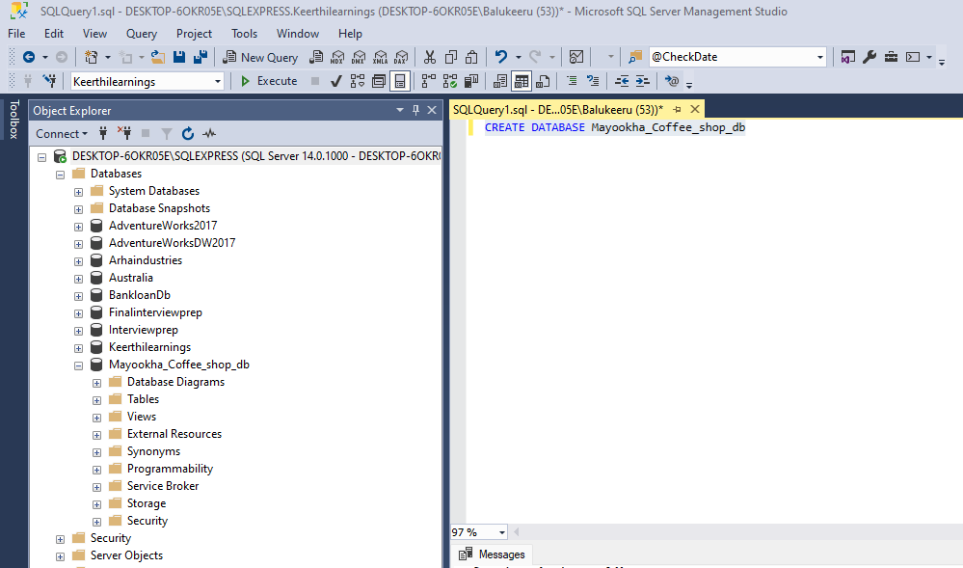

# **Stage 2: Importing the data into SSMS:**

Importing the data into the SSMS can be done in many ways depending on the data we are dealing with. We have multiple options like SSIS, Azure data factory, flat files etc. Each method has its own use cases and is suited to different scenarios based on the complexity of the data and the requirements of the import process.

Now our database is a flat file in excel. (Read Stage 1A For clarification)

* Right click on database name
* Select Task (From the menu)
* Import flat file(From the menu)
* Click next (on Pop up – introduction) and browse location – Here we can give the table name as well as schema.
* We will get a data preview – click next
* We can modify the columns by renaming them(Optional), data types(Optional), selecting which one would be the primary key, and allowing nulls(Optional)
* Click Okay and Importing is done successfully.